My Year of Vertical Thinking (with apologies to Joan Didion)
By Ginny Speaks, NBCT

Teaching might look easy to the untrained eye, but even after 20 years of high school English, I still work at it every day. Most of us do. In the spring of 2015 after what I felt was some of our best teaching, we were confident our assessment scores would reflect the countless hours of rigorous lessons that both the teachers and students experienced. The result: A basic flat line in reading. Though our scores were still relatively strong, and we remained a school of distinction, across the board, our reading scores stood unchanged. We felt defeated. Scrambling to find where the problem lay, we sprang into action and began looking at everything from lessons, standards, and PLCs; from teachers and syllabi to administrators.

In August of 2015, I received an invitation from KDE’s Lauren Hill to Kentucky’s National Board Certified Teachers where she challenged us to join her as part of Classroom Teachers Enacting Positive Solutions (CTEPS) in becoming 21st Century teacher-leaders. Part of the call to action began with a task: identify an educational issue within our classroom, school, PLC, district or state, and try to find a way to solve it.
In an effort to uncover where we erred, I first took a closer look at our PLC. The current district model uses a prescribed data analysis, but our PLC believed that working more uniformly toward building units could move students towards proficiency. But aligning content for a school of 2,200+ students created more problems. We simply didn’t have the resources to align literary units. Teaching a novel unit at the same time would require over 500 novels of each book, a storage and budget issue. So, back to the standards, I went.
When the Common Core State Standards were originally unveiled in 2011, the new school year was already underway. We were overwhelmed with what seemed like a flood of new edicts to uphold. For years, our department has tried to vertically align our content, and prior to Common Core, we did a pretty good job. In the current context, however, each teacher interpreted the standards in his or her own way. This led to a glaring problem: the depth of student learning depended upon which teacher they had. The new standards were supposed to fix that, but instead seemed like our implementation presented a widening gap between teachers’ lessons and students’ achievement. “It’s everything all the time,” said a district resource teacher. It was a basic free for all and none of us, whether we admitted it or not, knew what we were doing.
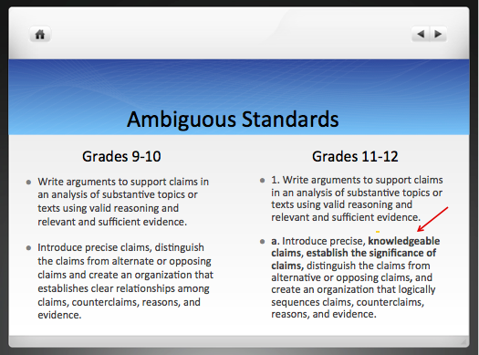

Once I began mining through KCAS, I found what I believed to be the source of our woes. How were we to increase rigor and deepen learning when the standards are so similar for Grades 9-10 and 9-10 and 11-12? What exactly is the difference between “precise claims and knowledgeable claims”? Can I really “distinguish a claim from an opposing one” if there is not a “relationship” to begin with? What does it look like?

I find many of the standards equally ambiguous. My CTEPS cohort remarked that this is not an ELA issue; they see it in science and math as well. This is not my area of expertise, and I didn’t know what to do with it, but at least I had a place to start.

The only way to deepen learning and increase rigor was to work vertically on our curriculum. Some schools already did this, but I didn’t know how. Through my CTEPS research, I found no concrete units vertically aligned with CCSS. We had to do it ourselves.

Some of my colleagues regularly eat lunch in my room, so we got to work beginning with our unit on argument. Since we had 10th and 11th grade teachers in the same room, we broke down the needs of each grade level, visually organizing them on my white board, moving major components from one grade to another. After a few lunch talks, MLA in-text citation and annotated bibliography moved to 10th grade freeing up weeks of instruction for 11th graders. We moved introducing counter-claim to 9th grade and focused 10th graders on developing theirs as it strengthens their own argument. By the end of the 9 weeks, we had completely rearranged our 9-11 curriculum for the argument unit.

During this process, I created a virtual file cabinet on Google Docs to house our work, accessible by the entire department. It’s one thing to hunt down a resource, but much easier to print a lesson or open a presentation from an internet-based departmental folder. We have committed to working on units 1-2 and populate the files by the start of school in August. Will this solve our flat scores? Only time and hard work will tell. But we are already seeing positive results. An 11th grade teacher remarked that the time saved on MLA has allowed her 2 weeks to deepen writing instruction which showed me we were on the right path. Moving counter-claim and accompanying activities to 9th grade will save me two days of instruction. Once we have it all in place, weeks, even months will be saved.

To suggest this is easy would be a lie; meaningful work rarely is. But it has been worth it. The collegial collective focus alone created a more cohesive department, and my students are more engaged as I teach unfamiliar content. How might other schools get there? First, isolation creates stagnation.
- Strive to create common planning or at least common lunch to create a team mentality.
- Move PLC teams away from grade level to vertically aligned ones. It’s hard to build anything if one hand doesn’t know what the other is doing.
- Instead of data mining, set time aside on professional development days for meaningful collaboration.

As my time with CTEPS comes to a close, I know that my year of vertical thinking will continue. The alignment bell can’t be un-rung. When school begins in August, my department and I will have a clearer vision and better resources to begin the school year.
Identifying problems is the easy part; finding solutions takes work. Like me, one can stay in his or her own educational lane for a long time, but when a problem hits home, ignoring the call to leadership isn’t quite as easy.

