A Journey through Reading: Challenging Struggling Readers to Find Their Inner Reader

How might I assist the struggling readers in my 4th grade class reach or surpass grade level reading, and foster a love of reading?
In September of 2015 this was my big question and my challenge. Each year since beginning my teaching career I have faced this challenge. This year I wanted to conquer this challenge by being intentional with my teaching and keeping data to drive my instruction. I was chosen to take part in a group of Kentucky teachers who want to use their leadership to improve student learning. The group is called Classroom Teachers Enacting Positive Solutions (CTEPS). I chose this challenge for my project because I know that the need to catch students up to grade level reading abilities is imperative to their future.
School Environment and Climate
Bates Elementary is one of 90 elementary schools in Jefferson County Public Schools. The school is located in the far southeastern part of the county and serves students in the surrounding neighborhoods. The school’s enrollment is 552 students in Kindergarten to 5th grade. There is no pre-school program but is a site for CEP (Child Enrichment Program run by the Y) before and after school care. 65.7% of the population is white, 15.6% African American, 10.3% Hispanic and 8.4% other. The school has a 52.3% Free and Reduced Lunch population and is part of the federal lunch program in which all students in the school receive free breakfast and lunch. Attendance rate for last year was 95.7%. The school is not a Title 1 school.
This is my second year teaching at Bates. Family participation is strong with a large PTA that plans many activities for the school. Administration is supportive and the school has made strong gains academically over the past few years. According to KPREP (statewide assessment) in 2012-2013, the school’s overall score was 55.3 and in 2013-2014 it was 68. This past year our score was 67.4, 71 percentile in the state and classified as Proficient. In the area of reading performance, Bates scored 56.4% proficient/distinguished as compared to 47.9% in the district and 52.4% in the state.
The school has a large assortment of extracurricular activities including Quick Recall, Future Problem Solving, basketball, cheerleading, soccer, cross country and Young Rembrandts. The school also has a Family Resource Center that supports families in removing barriers that interfere with the child’s learning.
I am among 3 fourth grade teachers. We all teach reading to our homeroom classes and departmentalize for the other subjects. I teach math to 3 classes, while my colleagues teach writing, social studies, and science. My reading block is 85 minutes long without interruptions. This year we have begun using Journeys (Bauman, Chard, et al, 2014) as a reading program to support our teaching of the Common Core Standards. I personally see many benefits of the reading program, but we have found it challenging to work within the framework of our district assessments. My team plans together for reading and attend weekly PLC meetings to analyze data and decide our next steps. In my classroom, I use the Daily 5 (Boushey and Moser, 2006) as a framework for literacy centers while I work with small guided reading groups. On a typical day, I spend 30 minutes in whole group instruction using Journeys or other outside resources and instruct two reading groups for about 25 minutes each. Daily I meet with my Tier 3 students and 3 times per week meet with my Tier 2 students. When time permits I meet with my Tier 1 students but mostly they do independent reading and are given activities that support the current reading standard we are working on.
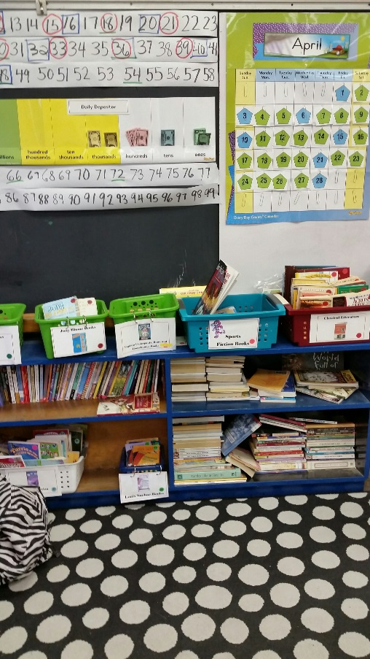
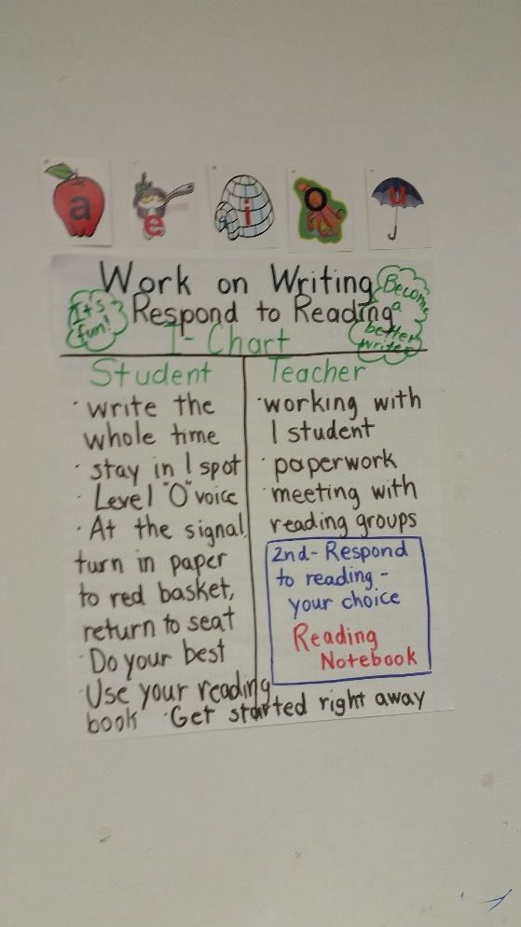
My philosophy is that students should be reading and writing throughout most of the school day. My Daily 5 activities include Read to Self, Read to Someone, Listen to Reading, Work on Writing and Word Work. My students know that when their work is finished, whether it is reading or math, they are to pull out a book to read or free write in a notebook. Students have book boxes that they carry to their other classes that contain the materials they need for class as well as several books to read. I have an extensive classroom library that includes as many non-fiction books as fiction. Many of the books were provided by the district but most are my own. I have also subscribed to magazines: ZooBooks, National Geographic Kids and Time for Kids. My students are allowed to browse the classroom library that has the books grouped according to biography, fiction animal books, nonfiction animal books, mystery books, picture books and many more. My students know that during Read to Self they are allowed to lie on the floor with a cushion so that they are comfortable reading. District specialists and coaches have told me in the past that students shouldn’t be just reading but responding to their reading with writing. I disagree. Students must learn to love to read for the sake of reading. Nothing gives me more pleasure than seeing several students lying quietly on pillows or bean bags reading to themselves. In fact, several times throughout the day I have to tell students to put their books away so that we can do math. I find that a good problem.
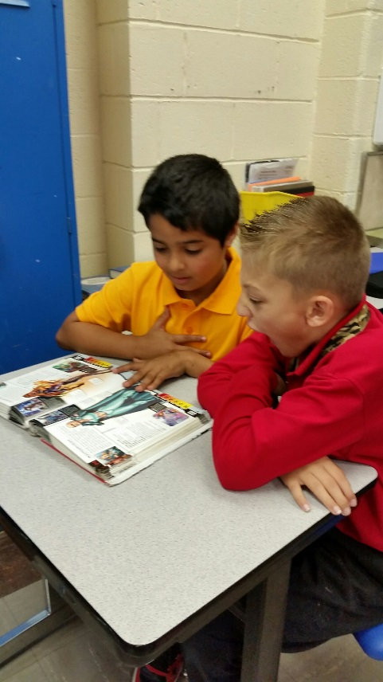
In my research I discovered a book that met my philosophy for reading. The Book Whisperer (Miller, 2009) is about awakening the inner reader in every child. I also believe every child has an inner reader but it takes a little more effort for some children than others to find that inner reader. One quote from the book that struck me: “Because reading has more impact on students’ achievement than any other activity in school, setting aside a time for reading must be the first activity we teachers write on our lesson plans, not the last.” Of course, I have “Read to Self” built into my daily lesson plan and train my students to read independently when they are done with their other work, but I began to think about my students’ morning routines. I have always provided my students with “Morning Work,” photo copies of review activities to keep them busy while attendance and homework check-in was taken care of. In her book, Ms. Miller indicated that that such a time used for independent reading would benefit students. Her feeling was that reading would make more of an impact on student achievement than review activities. In October, I gave up assigning morning work to my students and trained them to read silently when entering the classroom in the morning. I never looked back! Students, for the most part, were eager to begin their day reading or browsing the library for a book and I no longer had to make copies of morning time checking it.
Identifying Student Reading Levels
In September of this school year, I gave each of my students a DRA (Developmental Reading Assessment, Edition 2 {Beaver and Carter, PhD, 2006}). This is the assessment required by my school to tier students and also group students for guided reading. The DRA includes reading engagement, oral reading fluency and comprehension. I identified 7 students out of my 28 total who were reading significantly below grade level. Since that is one fourth of my class I was concerned but not surprised. Over my 16 years of teaching, I have found that there is a significant number of students who are not at grade level for reading. I have discovered many reasons for this including the student’s home environment, past ineffective teachers, learning disabilities, misguided teaching methods and too many distractions. I am also well aware of the studies that say students who are behind grade level reading in the 3rd grade have little chance of catching up with their peers. Bates, thankfully, has a different expectation. All instructors work together with diligence to ensure that students have every opportunity to read on grade level.
In past years, we have been told that all Tier 3 students should be using a computer program daily to assist them in improving reading abilities. Thousands of dollars are spent on these programs and statistics are given, but I find them mostly ineffective. Nothing helps students to improve their reading than good daily guided reading with a trained adult, and being immersed in quality reading materials. Fortunately, since being at Bates I have been allowed to make my own judgements for how I will provide interventions for my Tier 3 readers.
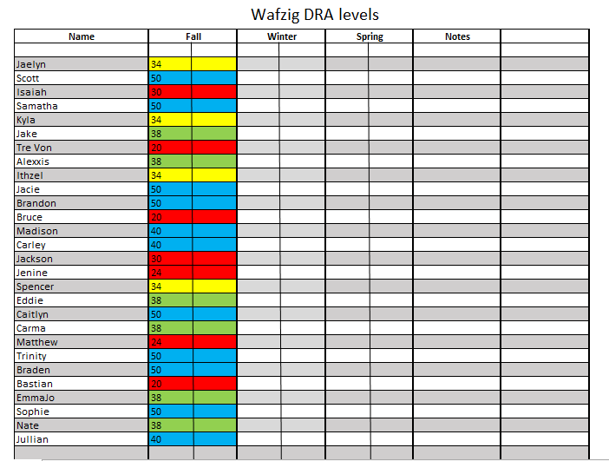
Our school has decided that to be on grade level, students should be reading at a 38 DRA level at the beginning of 4th grade, DRA 40 in the winter and leave 4th grade reading at a DRA 50. As I said, 7 of my students were reading 2 or more years below grade level, 4 students slightly below grade level, 5 on grade level, and 12 students above grade level. The lowest DRA score was 20 (beginning 2nd grade) and the highest 50. This is a wide range but judging by past experiences, typical for a class. My identified 7 Tier 3 students included three DRA 20s, two DRA 24s, one DRA 30 and one DRA 28.
Isaiah was DRA 30. He did fine in the area of comprehension but scored low in oral reading fluency. His rate was average and accuracy above average, but he had difficulties with expression and phrasing. Isaiah is an African American who gets much support at home from his mother. She assists with his homework nightly and has him read aloud for 20 minutes a night. According to a survey filled out by his mother, he enjoys reading Marvel, Transformers and Minecraft books that go along with the toys he likes to play with. She says that if he is reading something he enjoys, he reads well orally and comprehends without problems. On his student survey, Isaiah said that he likes to read but finds some of the words hard for him. When asked what he would like help with, he said math. Isaiah is a pleasant boy who has many friends. He did not participate much in the beginning of the school year, but as time has gone on he raises his hand more to join in class discussions. Beginning in November, Isaiah was identified to work with a trained adult using Comprehension Plus (Lapp, D. and Flood, J., et al, 2002), a resource that provides a variety of activities to improve comprehension and assist students in using context clues to figure out the meanings of unknown words. Isaiah is instructed in this small group 3 times a week for 25 minutes each. As Isaiah’s confidence increased his oral reading fluency has improved.
Bruce is a white student reading at a DRA 20 at the beginning of 4th grade. He came to our school after the start of 3rd grade not recognizing most letters. He had been in preschool for two years in a different district in Kentucky. According to his enrollment history he attended kindergarten in another district and then enrolled in the same school for 1st grade but did not show. There is a gap in his school history for 1st and 2nd grade and then he enrolled at Bates for 3rd grade a few weeks after school started. He is a sharp boy but has a reading disability that I recognize as dyslexia. He also has undiagnosed ADHD and other emotional problems. He has been hospitalized four times throughout the school year but would not continue with prescribed medication once he was released. In March, after the last hospitalization he had been routinely medicated and performing much better in class. After Spring Break; however, he has not been medicated and behaviors have escalated resulting in referrals and suspensions. He has done no significant amount of work or has shown any effort since Spring Break. Bruce lives with his mother and step father who at times want to support him but often do not follow through. Mom has an unidentified illness and has had to have several different treatments, and dad is handicapped. I have not met either in person but have spoken to the father via e-mail several times. Our Family Resource Center has made home visits along with our counselor. The last course of actions is that he has been referred to Child Protective Services since he is not receiving medical treatment prescribed to him.
With all of these difficulties I have tried to give Bruce as much support as I can to become a better reader. He scored average on fluency and comprehension on the DRA. His written answers were very difficult to read because of poor spelling and handwriting, but I was able to decipher enough to tell that he read and comprehended the book. Bruce’s parents did not return the parent survey, but his past teacher completed a survey. She said that he seemed to not like reading because it was too difficult for him to sound out words and he became frustrated. She also said that his attention problems prevented him from focusing during guided reading. I think this teacher did a remarkable job since he came to school reading on a kindergarten level and left 3rd grade at a DRA 12. She believed he could have scored higher but he did not give the effort needed. Bruce told me he did a reading program over the summer at the library. I believe this is why he was able to score a 20 at the beginning of 4th grade. According to his survey, Bruce does not like to read because it is boring. The hardest thing for him is the words and the easiest is the pictures. He would like more help with words. From his responses and attitude at the beginning of the year I could tell Bruce was suffering from low self-esteem.
In November, Bruce began receiving interventions with a small group of students with Mrs. Wintergerst, our literacy specialist. Mrs. Wintergerst was moved from a 2nd grade classroom into the position as literacy interventionist. Bruce loved going to Mrs. Wintergerst. She is high-energy and uses many whole brain teaching strategies. These strategies kept his attention and he made much progress. Mrs. Wintergerst spent her time with these students practicing fluency and word attack skills. She worked daily with this group for 40 minutes per day at the end of the day. After several months, she focused on comprehension and written responses. Using her data and the data I kept, we are recommending him for testing in the area of reading. I have also collected data to have Bruce tested for his attention problems.
I attempted to test Jackson at a DRA level of 30. This is the level that he left 3rd grade, but because of difficulty answering comprehension questions and below average reading rate, he did not pass this level. Spelling is also difficult for him. According to his survey, Jackson said he liked reading especially books like Bone, Big Nate and Diary of a Wimpy Kid. He said he had difficulty with spelling out words and wanted help with spelling out his words. I took this to mean that he had difficulty matching letters to sound. Jackson’s parents also said he enjoyed reading but becomes anxious when he has to read in front of a group. His past teacher indicated that Jackson had little motivation to do well, but that he worked much better in a small group rather than a whole group setting. She indicated that the parents seemed concerned but provided little follow through. I have found the same issues this year. Jackson has been at Bates since kindergarten and according to past teacher notes has had a lot of difficulty focusing and following school rules. I find that Jackson must have lots of structure and reminders of his behavior. Behaviorally, he has done much better this year but as spring came he was not giving much effort on his work. Jackson enjoys math and loves to participate in math class. Jackson makes little effort on his homework and reading assessments so his grades do not reflect what he can do.
Jackson also works in a group with Isaiah doing Comprehension Plus. He has made much progress this year but I worry about the lack of motivation. I plan on spending some one-on-one time with him to assist him in answering short answer and extended response questions. I believe he could benefit with the help of sentence frames for beginning his answers.
TreVon is a bi-racial student reading at a DRA 20. I tried assessing him at 24, which is where he left 3rd grade but weak oral reading fluency prevented him from passing. According to his teacher last year he was level 24 in the winter and stayed at the same level in the spring. In the teacher survey she noted that TreVon like reading but found on grade level books too challenging. He read well on his own level when he didn’t have to think about sounding out words. I did not receive a survey from his parents, but I do know that his grandparents are very involved in his life. They have expressed concern that TreVon is not progressing as a reader. I gave several suggestions for them to work with him at home. TreVon is a well-behaved student and usually tries his best. He has the desire to become a better reader and I feel like he’s made lots of improvements this year, but weak oral reading fluency has prevented him from moving up levels. Rate and word accuracy is much improved from the beginning of the year.
TreVon is also working in a small group with Mrs. Wintergerst. He also enjoys his time with her and is the only one in the group who does his fluency homework. Mrs. Wintergerst provides a fluency passage for the students to practice nightly at home with an adult. Since after the winter break, a second grade teacher in our building works with him about two times per week. She is working on her master’s degree as a reading specialist and needed a student to work with, assess and provide anecdotal notes. I suggested TreVon because he has the desire to improve his reading. Being a classroom teacher her time is limited so there are times she must work with him during his recess. He has made no complaints about this.
According to his survey, TreVon likes to read because “it’s like you are really in the book.” He says that he has difficulty reading the words and wants help learning the words. As TreVon has become more confident in chunking and sounding out new words, he has participated more in whole group reading instruction. He always participates well in small group instruction.
Matthew is a developmentally delayed white student. He was born at 26 weeks and, according to his mother, with the following: plagiocephaly (head not developing correctly), torticollios (could not turn head in both directions), allergies, chronic ear infections and a sleep disorder. Upon appearance, Matthew looks normal and can communicate with his peers and adults. Mom has sole custody and receives SSI benefits for Matthew who has been identified 2 years developmentally delayed. He has struggled in school since kindergarten and his mom is concerned about him working in a grade level class.
He was tested in 2011 because of mom’s concerns. Results of the evaluation conclude that Matthew was performing within the within the average range for general intellectual abilities. His academic skills were below average range with reading and writing within the average range. In third grade, mom again stated concerns and wanted him tested. His teacher collected data and provided multiple interventions, but the counselor chose not to test him at that time because of historically poor attendance. This year, mom has asked again to have him tested. According the counselor, students cannot be identified developmentally delayed beyond the age of 8. I have provided data and interventions for Matthew and it was agreed at our last RTI (Response to Interventions) meeting that he will be tested. As academics have become increasingly difficult, Matthew has had a harder time grasping concepts.
I assessed Matthew at a DRA 24 at the beginning of the school year. He was able to read the text at 98% accuracy but his rate, expression and phrasing were low. Matthew also has difficulty comprehending text when reading to himself and answering in written responses. When working one-on-one with Matthew, he can read and comprehend fairly well orally. Matthew also worked in a small group with the literacy specialist, Mrs. Wintergerst. He has made small gains and sometimes will read aloud during whole group instruction.
Matthew is well-behaved at school and works well independently. His mother says that there are tantrums at home and difficulty getting him to do his homework. At the last conference we decided to have Matthew do below grade level homework so that he wouldn’t be so frustrated. He reads aloud nightly for 20 minutes with his mother. According to the parent survey, Matthew likes to read sometimes. He has a hard time understanding what he has read and decoding new words. In his survey, Matthew said he likes to read because “it’s good to read because you learn new things.” He expressed a desire for help with the words and getting more books. Matthew’s writing is very weak. Spelling is difficult for him and he does not write in complete sentences or thoughts. During our WIN time (interventions/enrichment) I have worked with Matthew and other students in answering questions in complete sentences. For Matthew, it does not carry over to his independent work unless I prompt him.
Jenine’s family is originally from Jordan and they speak Arabic at home. According to an English Language Assessment report in 2011, she qualified for ESL (English as a Second Language) services but her family refused services and asked that she participate full time in a mainstream classroom. This could be because Bates does not have an ESL unit and her family did not want her to move schools. Jenine does have a PSP (Program Services Plan) which allows her to get a reader, prompting and cueing, and extended time. According to a 2013 IEP, Jenine’s developmental delay in the area of cognition adversely impacts her academic performance in the classroom. Up until 4th grade, Jenine received services for reading, math and writing for 90 minutes a day in a Special Education class. Up until the fall of 4th grade, Jenine was also receiving speech services 30 minutes per week. Jenine is struggling in 4th grade without special services. She works hard and always tries her best, but her cognitive abilities do not allow for full understanding of many concepts. Behavior is generally good, but she often becomes distracted and gives off task answers to academic questions.
I assessed Jenine at a DRA level 28 at the beginning of the year. She did well on the oral reading fluency scoring 98% accuracy, but was not able to pass that level because of very weak comprehension. Her written answers sometimes did not relate to the text read or were very brief with little content. Jenine filled out her family survey herself. She said she had to help her mom because she can’t write. Jenine has mentioned in class that her mother didn’t get to go to school because of her religion. In the family survey she said she didn’t like to read because she can’t stay focused. When asked “What do you think your child struggles with when it comes to reading?” Jenine wrote, “Yes so bad.” On her student survey Jenine said she did not like to read because books take too long. She said the hardest thing for her is focusing and she needed help understanding books and remembering them.
Jenine works very well in a small reading group. She enjoys reading aloud and sharing her answers though sometimes they don’t make sense and the other students make fun of her. She is the only girl in her guided reading group so I try to keep her close to me and prevent the others from teasing her. According to her PSP (Program Services Plan), Jenine gets a reader on all assessments. This spring she has begun to ask to read and do her work on her own. She takes her time and tries her best, but still the comprehension is not there.
Bastian is a white male with an IEP (Individual Education Plan). His accommodations include a reader, prompting/cueing, a scribe for longer written responses and extended time. He receives 60 minutes of services per day and 30 minutes of speech therapy one time a week. Bastian left third grade at a DRA level 20 and that was the level he assessed at for beginning 4th grade. His main difficulty is reading fluency and comprehending text that has not been read to him. He comprehends very well when read to and can make some higher level connections when speaking about the text.
Bastian is generally a well-behaved, pleasant child. He enjoys socializing with his peers and is involved in Cub Scouts. His parents are involved with his education and always accessible when difficulties arise. Bastian sometimes gets off task when doing independent work and has to be prompted to continue. He sometimes gets frustrated and then refuses to do anything. He can be sneaky and hide his work so that he thinks I won’t notice that he has not turned it in. This second half of the year, he has not been doing his homework.
According to his family survey, he has been read to often and likes graphic novels. His parents agree that he has a high level of comprehension when read to. On his survey he indicated that he did not like to read because it is boring. The hardest part for him is figuring out the words. He says that he like comics and I noticed that that is the type of book he chooses from the school library.
Addressing Student Needs
After working a few weeks with these students I noticed some common weaknesses. All of them had difficulty spelling words and decoding unfamiliar words with more than one syllable. The students also had a common strength – they all could easily read basic sight words. Also, the students love being read to. When they find high interest books on their level they also enjoy reading to themselves. Only Jackson and Isaiah would be found reading at extended amounts of time on their own. After five weeks of Daily 5 practice with building stamina when reading independently, I found that they could all read extensively for 20 minutes if they were not distracted.
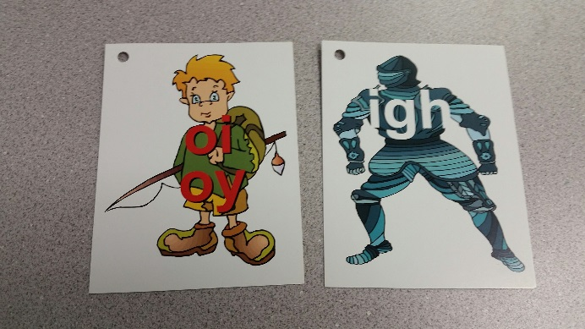
While doing some research, I stumbled on a website created by Diane Craft, MA, CNHP. She is an experienced special education teacher who has worked with struggling readers in grades 2-8 in her resource room. Many of the students she works with have dyslexia or another reading disorder. She has developed a Daily Lesson Plan for Struggling Readers based on research and her experiences in working with students with reading difficulties. She claims to be able to raise a child’s reading ability by 2 years in one school year. The reading session should be 45-60 minutes per day for at least 4 days per week. Already I found a glitch since at best, I have 25 minutes a day with these students in a small group, not one on one.
The Lesson Plan includes decoding practice using right brain phonics. I purchased her Right Brain Phonics Reading Book (Craft, 2000) from Amazon and was so impressed that I purchased “Right Brain Multiplication Cards” to use in my math classes. The decoding units are in color and imbedded on the picture that gives the sound. This puts the left brain sound on the right brain picture, helping the child easily impress the sound unit in his/her brain. The book contains lists of words that gradually build on understanding of various decoding units beginning with short vowels. I also purchased the “Right Brain Vocabulary Cards” that coincide with the book. The Daily Lesson Plan also includes dictation where students write the words from the Right Brain Phonics Book, teaching sight words, pre-reading which includes reviewing and practicing the words that will be in the text, and oral reading. Craft suggests using Merrill Readers (Mercer and Rudolph, 1998) that have few sight words. The remedial readers contain words that students can sound out easily building on their learning. Since this was the type of books that I used to teach my son to read when he was four, I was very interested in locating them. Unfortunately, I found them too expensive to access for my purposes.
I needed a beginning assessment to gauge where my students were so I gave them the PAF (Performance Assessment Framework) Placement Test that I found online connected to Diane Craft’s website. The test is given individually and includes students reading isolated sounds, reading phonetic words, non-phonetic words, dictation of phonetic nonsense words (CVC words, short vowels with digraphs and blends, short vowels with initial blends), and dictation of non-phonetic real words. Once the assessment was given and scored, then you can tell where to begin with your students in the Right Brain Phonics Book and the Merrill Readers.
After giving the PAF Placement tests to all the students I found that Isaiah and Jackson scored the best but had some difficulties with short vowel sounds. TreVon, Jenine, Matthew and Bruce had a lot of difficulties with short vowel sounds. Bastian mainly had difficulties with the spelling of nonsense words. Bruce’s assessment contained the most difficulties which I predicted since I believe him to be dyslexic. All students did well reading sight words though they often had difficulty spelling them.
Because of common difficulties with short vowel sounds, that’s where I began in the Right Brain Phonics Book. I was disappointed to not have access to the Merrill Readers but I found leveled texts from Rigby (Rigby Literacy, 2003) that I began using with the students. After a few weeks working with my students I found that they were more interested in the guided reading books from Journeys than the low interest Rigby Readers. I hesitated because the lowest Journeys Readers were a DRA level 38, much too high for these students. I decided to give it try when several of the students grabbed the Journeys Readers from the reading table that I was using with another group. The Journeys Readers are high interest and contain the same vocabulary words that we work on during whole group instruction. These are words that the students find the meanings in context on Monday and discover in their anchor text throughout the week. The readers also stress the same comprehension skill focused on during whole group instruction. The readers were challenging but the students loved them. We read the pages together and I trained the group to keep quiet when another student was decoding a word so that he could work through the sounds on his own. I showed students how to cover up parts of the word to uncover syllables or base words that they already knew. They caught on quick! The biggest difficulty was having all students focusing on a page while another student was reading. This was a particular difficulty for Bastian and Bruce who preferred just to listen to someone else read.
Mid-Year Check-In
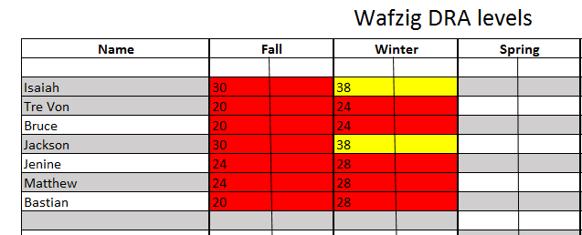
In January, I once again assessed students using the DRA. Isaiah made significant improvements reading at level 38, one level away from on grade level. Oral reading fluency was slow (in the instructional level) but accuracy was advanced. Written comprehension answers were in the independent and advanced area except for interpretation. His answer was too literal with little understanding of text implications. Jackson also scored a level 38. His oral reading fluency was similar to Isaiah’s but he was slightly weaker in comprehension, mainly because his answers were not thorough enough to show an in depth understanding. Consequently, I decided to move Isaiah and Jackson out of their current guided reading group to the next level. They were very pleased and proud of themselves and have continued to perform very well. They both needed this boost of confidence.
I attempted level 28 with both TreVon and Bruce but their oral reading fluency was too slow and comprehension was not there. I tested Matthew and Jenine at level 30, but Matthew’s oral reading fluency was too low and Jenine had significant difficulties with comprehension. Bastian was able to score at level 28 and his rate was in the instructional stage while word accuracy was 100%. I was pleased that three of my identified students were able to move two levels in less than five months.
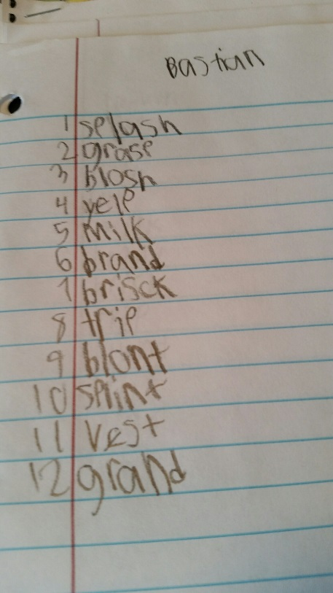
I continued working with this group daily (minus Isaiah and Jackson) for guided reading. We began by practicing letter, blend and digraph sounds using the Right Brain Phonics cards. Then I read words aloud with the particular sound or pattern that we are working on and the students write the words on a dry erase board. After about 10 words we review the spellings and talk about the sounds they may have missed. Every 2-3 weeks I gave them a written assessment to judge their improvements and what areas we still needed to work on. I also had students read individually from a list of words as an assessment. In all cases, students read words better than they spelled. All made improvements over time, but they still showed some weakness, particularly in the area of short vowel sounds. I was disappointed that I did not have enough time to take the students through the whole Right Brain Phonics Program, but I felt that I gave them enough of a boost so that they can decode words with confidence. All of these students now volunteer to read aloud in front of the class with confidence.
In April, I decided to use one of the classroom sets of books with my whole class. We had been reading and analyzing technical texts in preparation for the upcoming state assessment and my students were bored with this type of reading. Instead of the normal reading groups the students read Phineas I. MacGuire Gets Slimed (Dowell, 2010). We read as a whole group, with partners or independently. When the rest of the class read independently, I read the book with my guided reading group. Students read aloud some pages and I read aloud some pages. All students enjoyed the book and my guided reading group felt proud to read the same book as the rest of the class. The book is leveled for upper fourth grade students.

A .

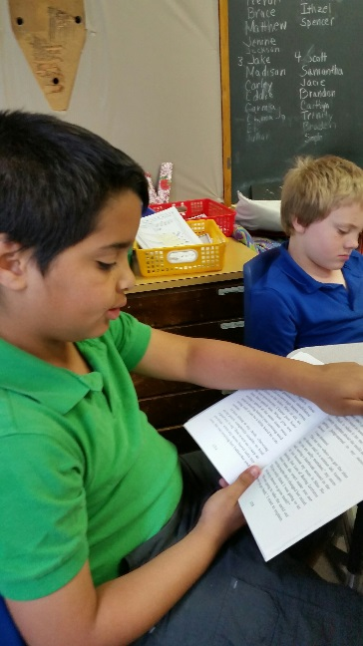

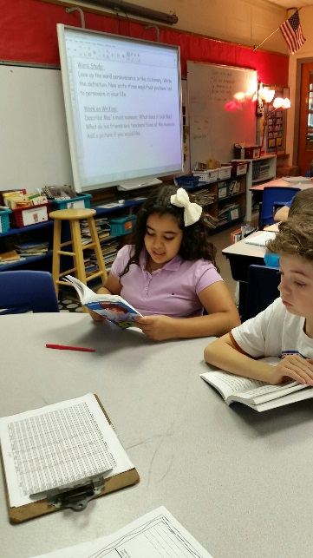

Final Assessment and Review
In May, I reassessed all my students again using the DRA. Isaiah and Jackson both scored a DRA 40 which is a middle 4th grade level. Both had fluency rates in the instructional level but were advanced for accuracy. Jackson was slightly lower in the area of comprehension mainly because he did not put much effort into his summary. Jenine and Bastian both scored a DRA 34. Jenine did very well on her oral reading fluency and her written summary. Interpretation questions gave her some difficulty. Testing Bastian was like pulling teeth. He did not want to answer the questions in writing so I dictated for him which is part of his IEP when he has longer passages to write. His summary kept his comprehension on the low side because he gave very brief phrases for each part. Jenine has moved up three DRA levels and Bastian four levels. I see Jenine often reading on her own in her free time. I attempted to assess Matthew at DRA level 34 but his comprehension was very weak. Also, his expression and phrasing were not consistent with the level. TreVon and Bruce both tested at DRA level 30. Both were in the instructional level for rate and advanced for accuracy. I believe their rate was low because they took the time to chunk sounds and figure out unknown words on their own. At the beginning of 4th grade, Bruce often would simply guess at a word by looking at the first letter. Now he takes the time to cover up endings and blend sounds together.
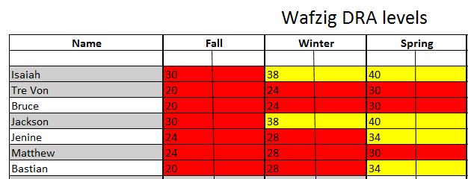
I now have four students reading slightly below grade level and three still in Tier 3. I am pleased with their progress and hope that they feel more confident in themselves and have begun to foster a love of reading. My next step was to survey these students on their thoughts.
I brought the seven students together in a group and we discussed their improvements based on DRA levels. I asked them each to complete a survey and all but Bruce were positive and proud of their accomplishments. Bruce was angry because I wouldn’t allow him to sit on top of another student while we were in the group so his answers were all negative. The six students said they all like to read and gave examples of what types of books they like to read. Several said that they were proud of their improvement in reading because they can read more now and at a higher level.
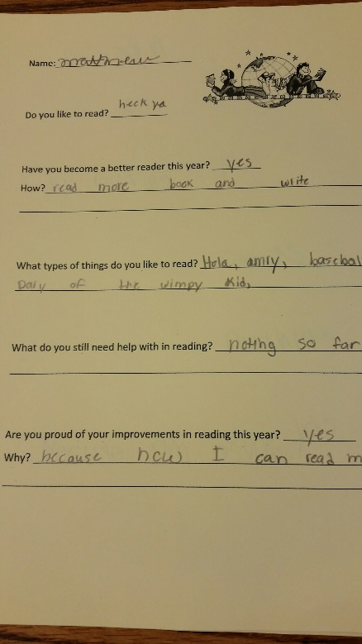
Reviewing back on the school year and rereading what I have written, I’m overwhelmed with the challenges I have faced. But these challenges are no different than any other public school teacher in our country. We teachers are faced daily with huge obstacles to overcome, but somehow we manage to teach.
I wanted these seven students to accomplish so much more. I was hoping to bring all up to grade level in reading. I found that my biggest obstacle was time. If I could work with these students for an hour daily or even independently instead of in a group, I believe I could accomplish so much more. Twenty-five minutes a day was simply not enough for me to accomplish my goal. However, I am pleased with the progress they made.
Each year, our district asks teachers, parents and guardians to submit a survey regarding the strengths and weaknesses of our schools. Each year I have made the following suggestion: Students not reading on grade level by the end of second grade should be placed in a specialized class in third grade that emphasizes improved reading abilities and is taught by a trained literacy specialist. These classes should be small and focus on literacy all day with an hour block devoted to mathematics. I believe this type of class setting would give most students the opportunity to catch up with their peers. So far, no one has responded to my suggestions, but I keep hoping…

Gemma Wafzig is a National Board Certified teacher. She holds a B.S. in elementary education from Western Kentucky University and a M.Ed. with an endorsement as a reading specialist from University of Louisville. She teaches 4th grade in Jefferson County Public Schools. Gemma resides in Louisville with her husband, Doug, three children, and one sassy beagle.

References

Baumann, J., Chard, D., and et.al. 2014. Journeys Common Core. Orlando, FL: Houghton Mifflin Harcourt Publishing Company.
Beaver, J. and Carter, M. 2006. Developmental Reading Assessment. Upper Saddle River, NJ: Pearson Education.
Boushey, G, and Moser, J. 2006. The Daily 5: Fostering Literacy Independence in the Elementary Grades. Portland, ME: Stenhouse Publishers.
Craft, D. 2014. Right Brain Phonics Program. Spiralbound.
Dowell, F. 2010. Phineas I. McGuire Gets Slimed! New York, NY: Altheneum Books for Young Readers.
Lapp, D., Flood, J., Moore, K., and Nichols, M. 2002. Comprehension Plus. Carlsbad, CA: Modern Curriculum Press.
Miller, D. 2009. The Book Whisperer: Awakening the Inner Reader in Every Child. San Francisco, CA: Jossey-Bass.
Rigby. Rigby Literacy. 2003. Barrington, IL: Harcourt Supplemental Publishers, Inc.
Rudolph, M., Mercer, C., and Wilson, R. 1998. Merrill Reading Program. Columbus, OH: McGraw Hill, Inc.

